**Apache Airflow and its components**

**Apache Airflow**

Apache Airflow is an open-source platform designed for the programmatic scheduling, monitoring, and orchestration of workflows. It enables data engineers and developers to define workflows as Directed Acyclic Graphs (DAGs) using Python code. This makes it easy to build, maintain, and scale complex data pipelines.

Initially developed at Airbnb in 2014, Airflow was later open-sourced and has since become one of the most popular workflow orchestration tools. Its core philosophy is “configuration as code,” allowing for better version control, testing, and collaborative development.

Airflow is especially powerful in environments where data pipelines require dependencies, retries, logging, and dynamic generation of tasks. It provides excellent support for workflow execution visualization, making it easier to monitor and debug tasks.

**Why Use Apache Airflow?**

Airflow excels in scenarios that demand robust pipeline orchestration with dynamic execution logic. Unlike cron jobs or shell scripts, Airflow supports the following features:

* **Dynamic pipeline generation**: Pipelines are defined in Python, allowing conditional logic, loops, and external parameterization.
* **Scalability**: Can be deployed across multiple workers and scale horizontally using Celery or Kubernetes.
* **Monitoring and alerting**: Integrated UI and email alerts help track task success or failure.
* **Integration**: Out-of-the-box operators exist for tools like MySQL, PostgreSQL, BigQuery, Spark, AWS, and more.

Airflow is not a data processing tool but an orchestrator. It doesn’t handle the data processing itself but manages when and how those processes run.

**Core Components of Apache Airflow**



**1. DAG (Directed Acyclic Graph)**

A DAG is a collection of all the tasks you want to run, organized in a way that reflects their relationships and dependencies. The key characteristic is that it has no cycles—tasks can’t loop back to earlier tasks.

Each DAG represents a workflow and is defined in a Python script. You can specify scheduling intervals, retry logic, task dependencies, and more.

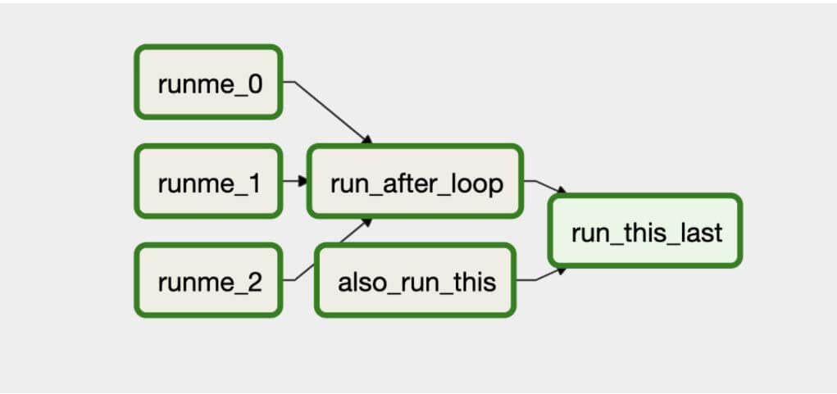

**2. Task**

A task is a defined unit of work within a DAG. Airflow provides different types of tasks through operators. Tasks can be simple shell commands, Python functions, or operations that interact with external systems like databases or cloud services.

Tasks are instantiated using operators and are executed in a defined order set by the DAG’s dependency rules.

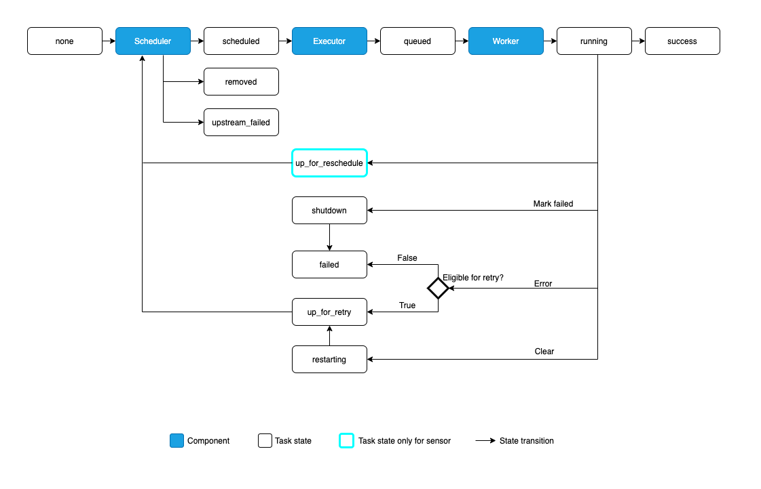

**3. Operator**

Operators define what actually happens during a task. Airflow comes with several built-in operators:

* **BashOperator**: Executes a bash command
* **PythonOperator**: Calls a Python function
* **DummyOperator**: Useful for placeholders or branching
* **BranchPythonOperator**: Allows conditional branching in DAGs
* **SensorOperator**: Waits for a condition to be met (e.g., a file to exist)

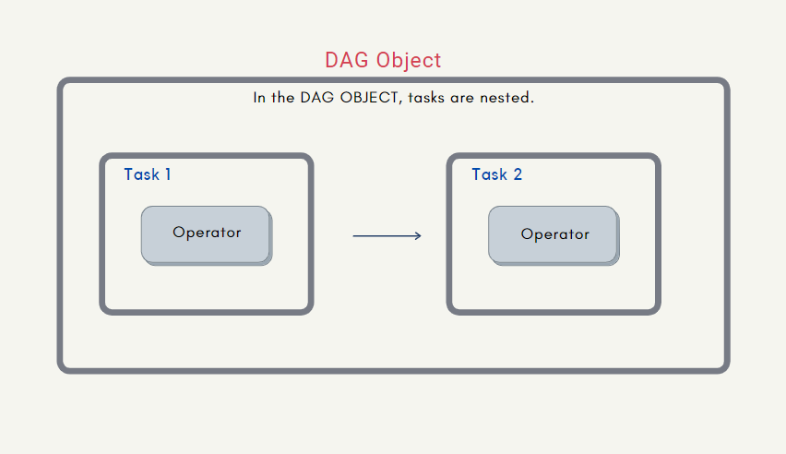

**4. Scheduler**

The Scheduler is the core service that scans all DAG definitions, triggers workflows at the specified time, and queues the tasks for execution. It continuously monitors the DAGs and assigns tasks to the executor.

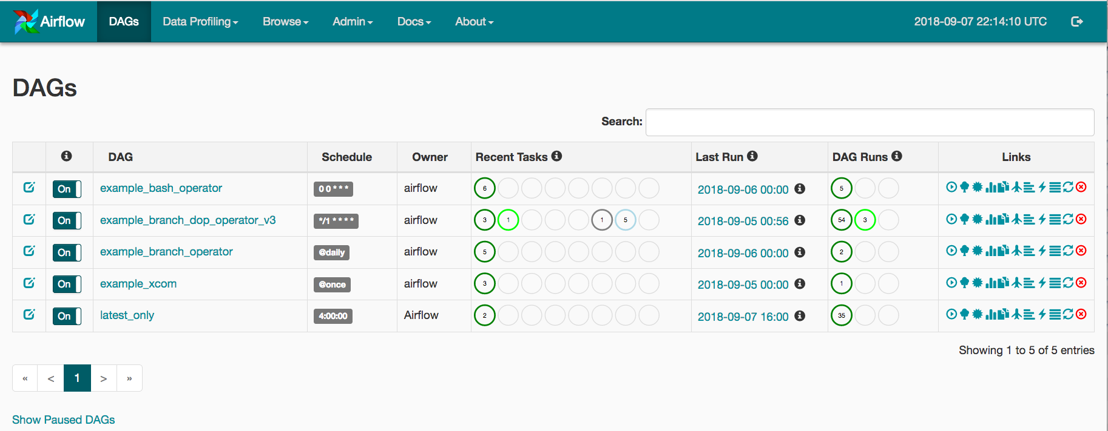

**5. Executor**

Executors are responsible for running the tasks. Airflow supports multiple executor types, including:

* **SequentialExecutor**: Runs one task at a time (for testing)
* **LocalExecutor**: Runs tasks in parallel using multiprocessing
* **CeleryExecutor**: Distributes tasks across a worker cluster
* **KubernetesExecutor**: Uses Kubernetes pods to execute tasks

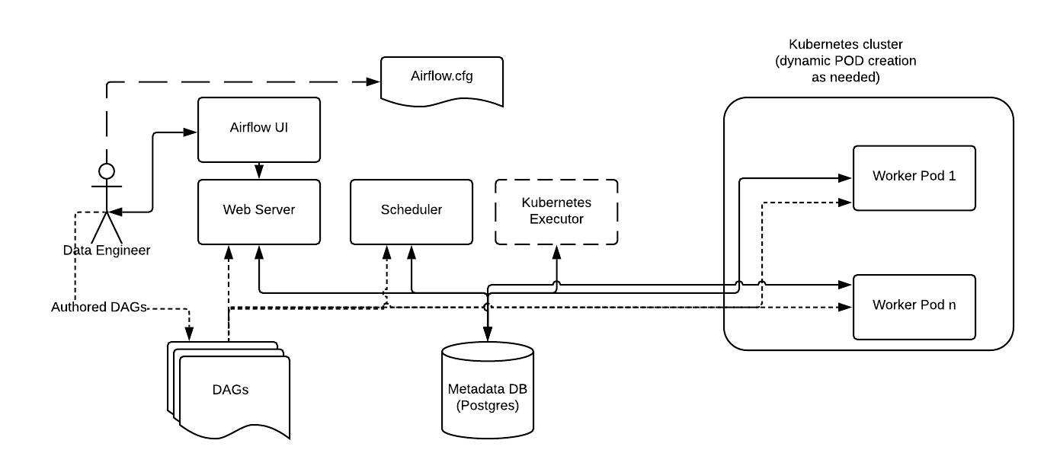

**6. Web Server (UI)**

Airflow includes a rich web-based UI that lets users visualize pipelines, monitor task statuses, and access logs. You can:

* View DAG structures
* Trigger or pause DAGs
* View logs of individual task runs
* Inspect variables, connections, and configurations

**7. Metadata Database**

The metadata database is a key part of Airflow. It stores information about DAGs, task instances, job status, and configuration. Airflow supports several RDBMS systems like PostgreSQL and MySQL.

This database ensures persistence and is essential for the scheduler and web server to function properly.

**Additional Features of Airflow**

**Dynamic Workflow Generation**

One of Airflow's major advantages is that DAGs can be generated dynamically. Since workflows are defined using Python code, you can use loops, functions, or external files to generate tasks programmatically.

**Extensibility**

Airflow is highly extensible. You can build custom plugins, operators, and hooks. It also supports integration with external tools via REST APIs or custom Python logic.

**Connections and Variables**

Connections allow Airflow to communicate securely with external systems. You can define them via the UI or as environment variables. Similarly, variables in Airflow are key-value pairs that can be accessed inside DAGs.

**Task Logging**

Airflow provides centralized logging for all task executions. Logs can be stored locally or pushed to remote systems like Amazon S3 or Google Cloud Storage.

**Conclusion**

Apache Airflow has become a fundamental tool in modern data engineering due to its flexibility, scalability, and robustness. By breaking down complex workflows into manageable tasks with clear dependencies, Airflow simplifies orchestration and improves reliability.

Its modular design, dynamic pipeline definition, and strong community support make it suitable for organizations of all sizes handling complex data workflows.

As data infrastructures become increasingly complex, tools like Airflow are essential for ensuring data pipelines are executed reliably, monitored effectively, and maintained with minimal overhead.